MyAgCentral 2.7.8 Release Notes
August 30, 2016

The MyAgCentral 2.7.8 release includes the following changes and several miscellaneous bug fixes.

Home:
- GFF Express Center – A multi-associated user must select an organization prior to clicking the Create a Work Order button. If an organization is not selected then a message will be displayed.
“Please select an organization for which you want to create a work order for and then try again.”

Once the organization is selected only the work orders allowed for that organization will be displayed.

If the user is not allowed to create work orders for a certain organizations based on their permissions and organization associations, then a message will be displayed indicating they do not have permission to create work orders for the organization selected.

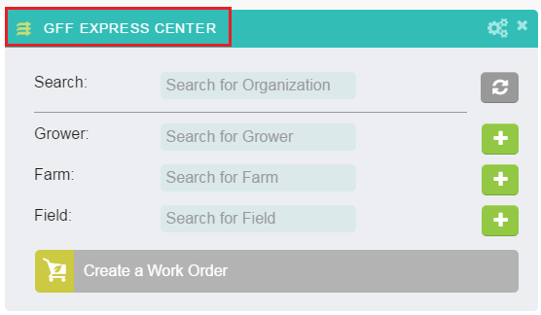

- GFF Express Center – Search box – An X clear option has been added to the Search box.

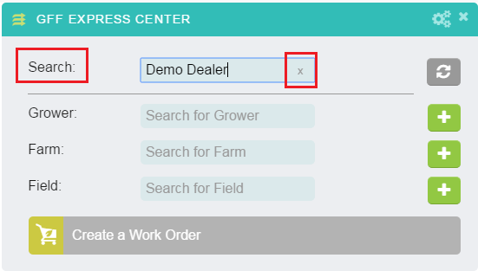

My Organization:

- Organizations Detail – Users with an Administrative role now have the option to delete Organizations including Locations, Growers and Farms within their hierarchy structure.

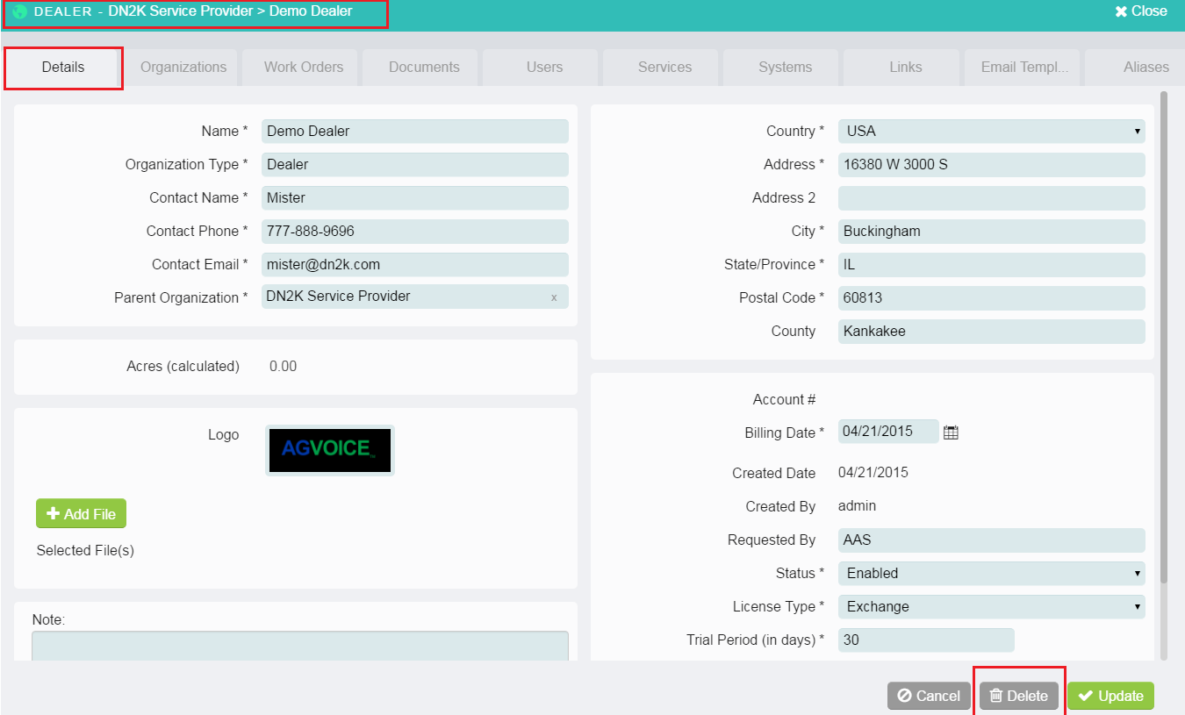

- User Add and User Profile – An SMS option for work order notifications has been added to the Add User and User Profile pages. A user can now choose to receive work order notifications via Email only, SMS only or Both. To set up SMS notifications the user will need to enter their mobile number and select their carrier.

The following carriers are supported.
- AT&T
- Verizon
- Sprint
- T-Mobile

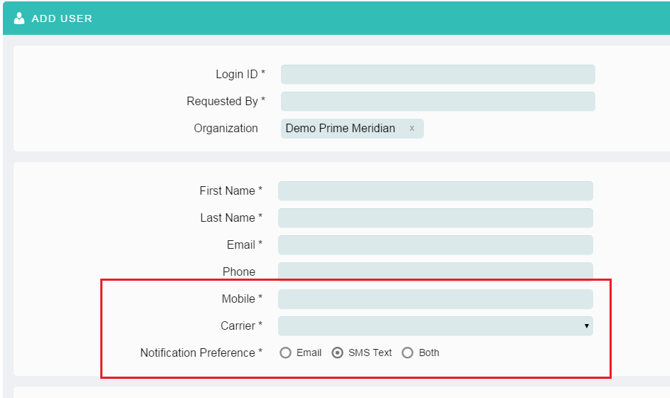
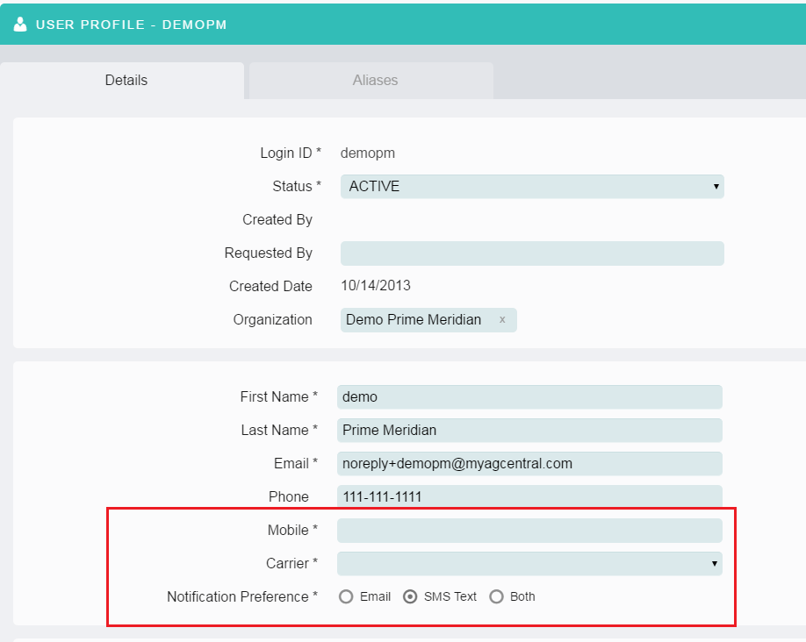

- Grower Organization – A new Crop Plan Form is now available when a Grower organization is selected in My Organization. The Retailer can create a Crop Plan for a Grower’s fields which includes the Seed Hybrid, # of Hybrid Acres, Population, Units, and Maturity. The completed form can be viewed and printed as a PDF document and can be used to discuss the Grower’s seed requirements for the next planting season.

Crop Plan Form
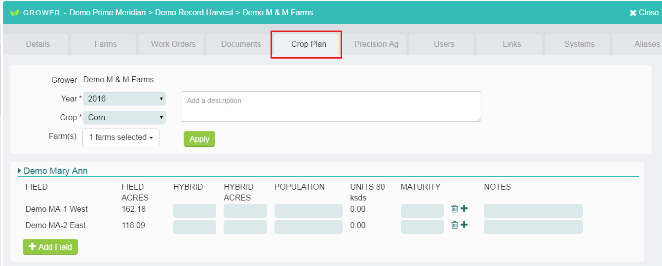

Completed Crop Plan
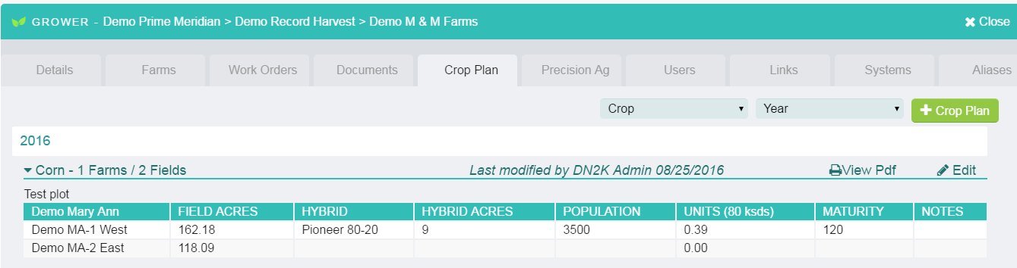

Crop Plan PDF
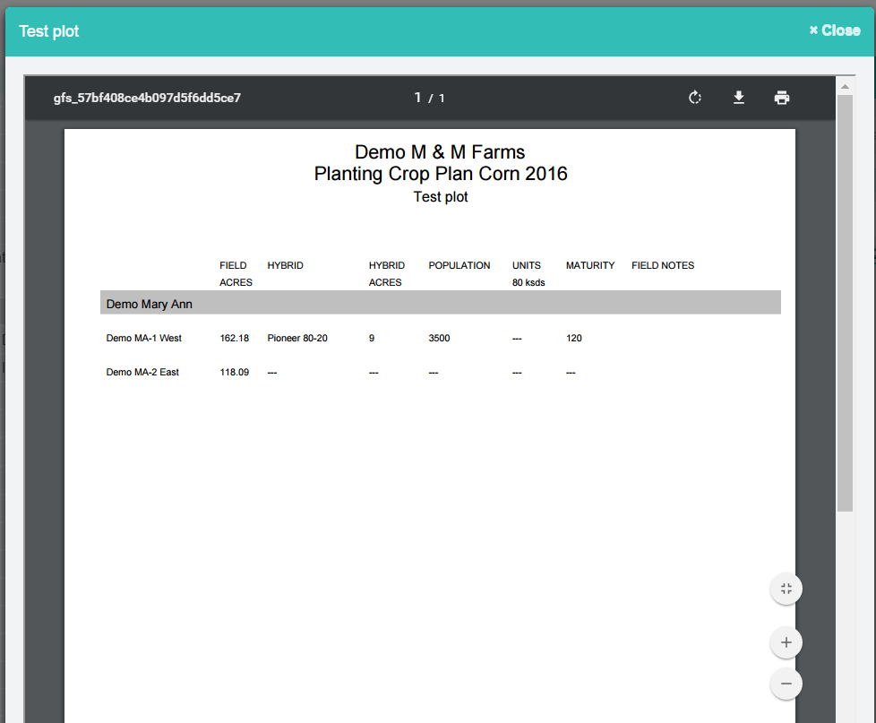

Fields Page:

- Fields Map Page – Add Asset – Draw a Field Boundary – When drawing a field boundary from the Field Map page the acres are calculated automatically. The acres are now rounded to two decimal places.

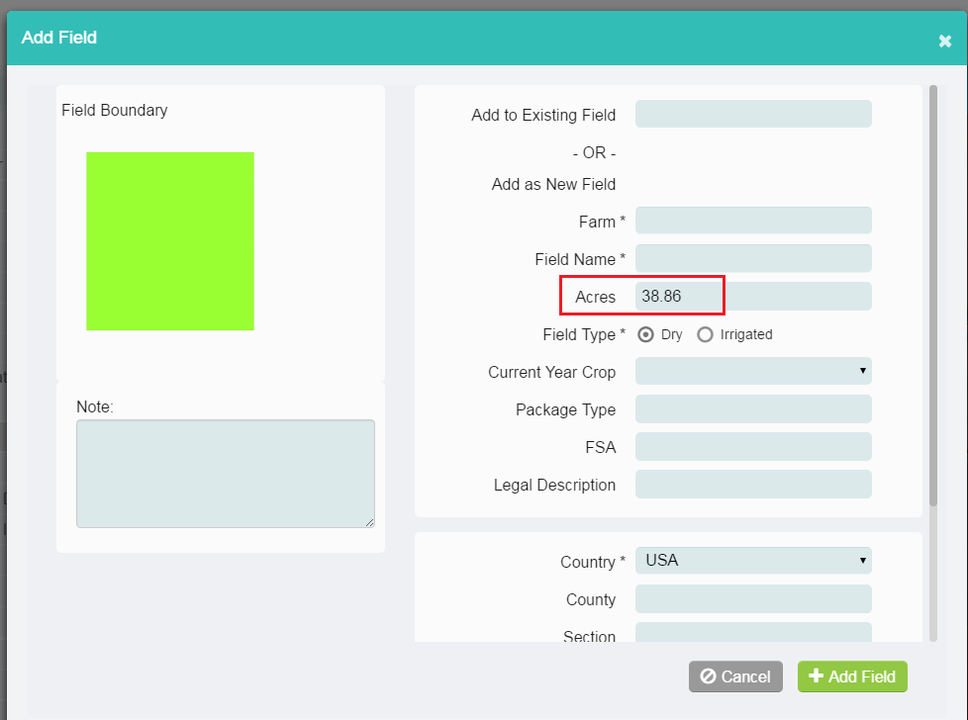

Documents Page:

- Transfer – The Transfer action is used to transfer files from MyAgCentral to the John Deere Operations Center My Files or to a WDT enabled machine. Previously the Transfer action could only be executed for a single file. The selection and transfer of multiple files has now been implemented.

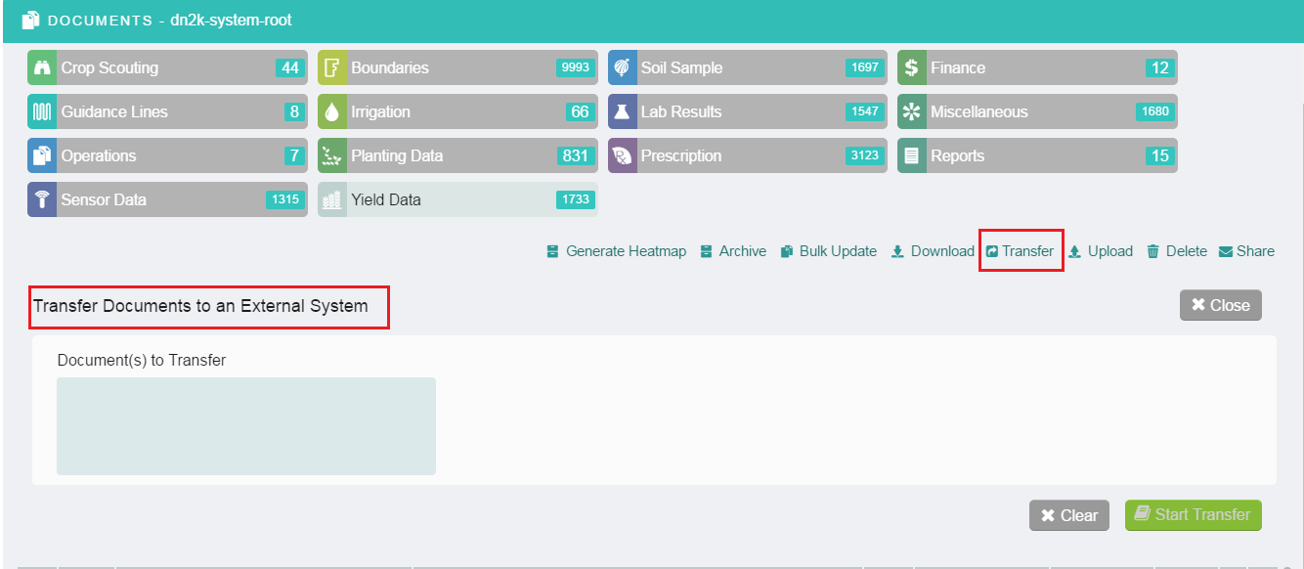

- File Name search – An X clear option has been added to the File Name search on the document page.

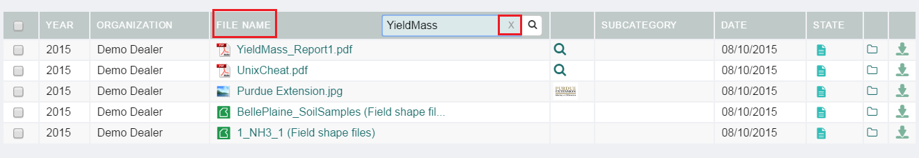

- Share Documents – The following improvements have been made to the Share Documents panel to improve usability.
  - Text has been changed from "Available Users" to “Select from Available Users"
  - Moved “Add an Email Address” underneath the Available User selection
  - Moved the “Documents to Share” list to under the “Send Documents To:”
  - Added the option to delete a document by clicking on the X following the document name.
  - Moved the Email size info closer to the documents list

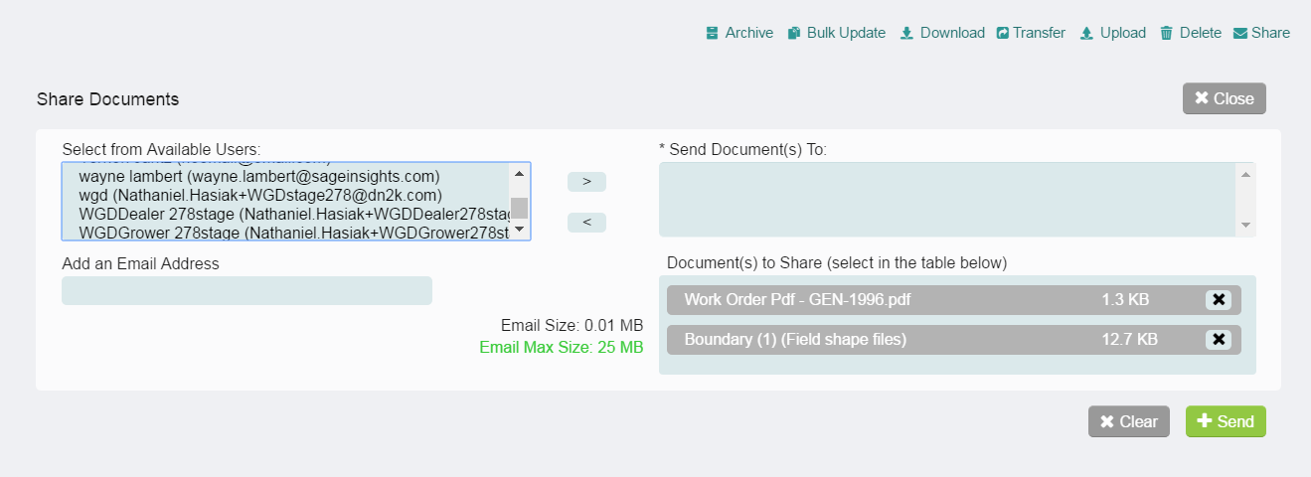

Work Orders Page:

- Soil Sample work order – A Midwest Lab Integration option is now available. The Midwest lab integration must be enabled from the My Organization system tab and requires additional set up prior to utilization in the Soil Sample work order. Please contact SageInsights Support to assist with enabling the Midwest Lab integration if you wish to use this new feature.

If the Midwest Labs integration is not enabled, the Soil Sample Work order tasks and steps have not changed and will follow the existing work flow.

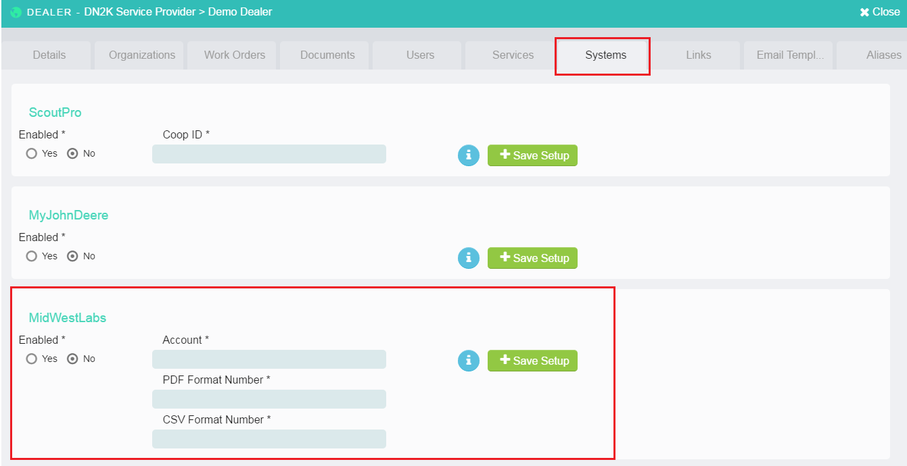

- Planting, Yield and Application Mapping Work Orders – When a Mapping work order is created a notification email is sent to the work order creator’s email, the grower’s email and any additional emails entered on the order form to inform the users a Mapping work order has been created.

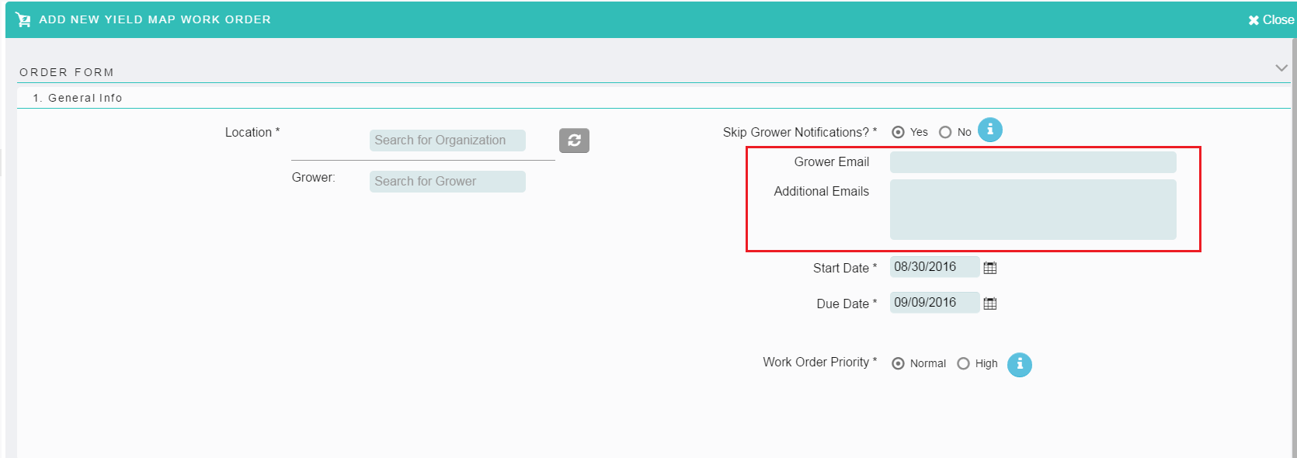

- All Work orders – General Information section – An X clear option has been added to the Location search field.

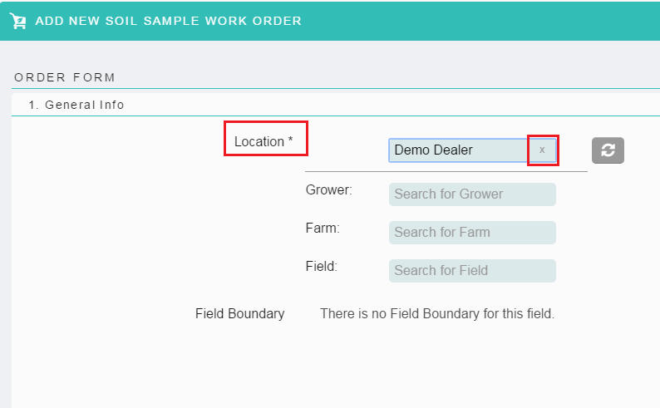

General:

- The Crop list has been standardized across the application to use the USDA crop list. The crop lists on the Fields page, Document page and in the Soil Sample work order now use the same master crop list. The crop list can be customized by organization. Please contact SageInsights Support if you wish to implement a customized crop list.

