MyAgCentral 2.7.5 Release Notes
July 28, 2016

The MyAgCentral 2.7.5 release includes the following changes and several miscellaneous bug fixes.

My Organization:

- Links Tab – An Info button has been added to the Links page to help the user understand what they are setting up on the Links page and how it will be utilized.

When the info button is selected the following message is presented, “Click on the Add Link button to add a link to the URL of an external system you utilize for your operations. A link added here will be displayed in the Links panel on the Home page.”

Fields Page:

- Fields Page- When viewing a field with no boundary on the Map View a modal window is now displayed. The user can then view the Field Details from the modal by clicking on “View Details”.

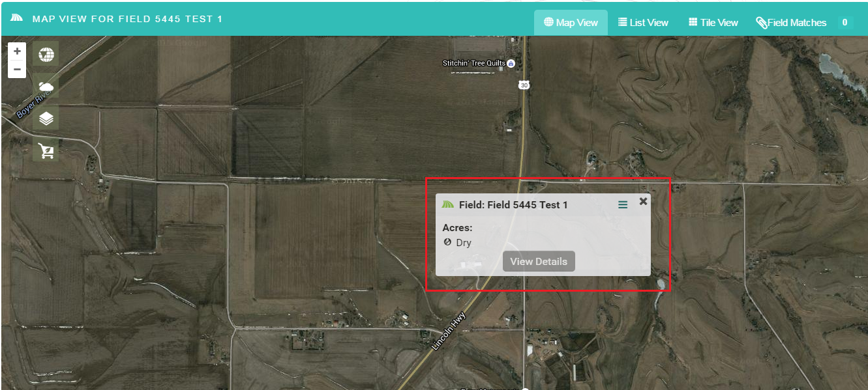

Documents Page:

- Documents Page –The work order reference box now points to the correct icon in the document list.

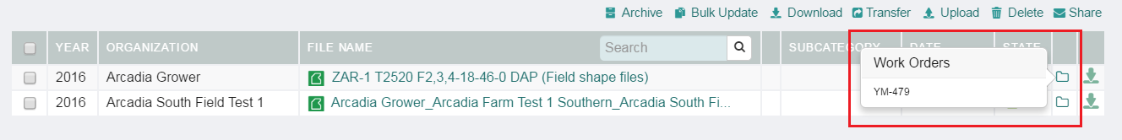

Work Orders Page:

- Work Order PDF – The Work order PDF is now displayed when using the Internet Explorer browser.
