MyAgCentral 2.6.9 Release Notes
April 13, 2016

The MyAgCentral 2.6.9 release includes the following changes and several miscellaneous bug fixes.

Users Profile:
- Preferences – An option to set the default number of entries to display in all table lists has been added. The user can set the table entry display to 10, 20, 50 or 100 rows. The user preferences table row display defaults to 100.

My Organization and Users:
- Organization Detail – The status field is now retained when a Logo is uploaded for the organization.

- User Detail – When viewing a User Detail, you are now able to select a new organization in the navigation panel and move to that organization.

Fields Page:
- Added the ability on the Field page List View to view the location of an asset on the map. The assets include Fields, Pivots, Tanks, Grain Bins, Video Cameras and Machines.

The steps below are using a Field asset as the example.
  - To view the Asset on the map from the List View click on “Actions” in the far right column.
  - This will display a “View Field Location” button.
  - Click on the “View Field Location Button.
  - The Map page is displayed and zoomed to the location of the field on the map.

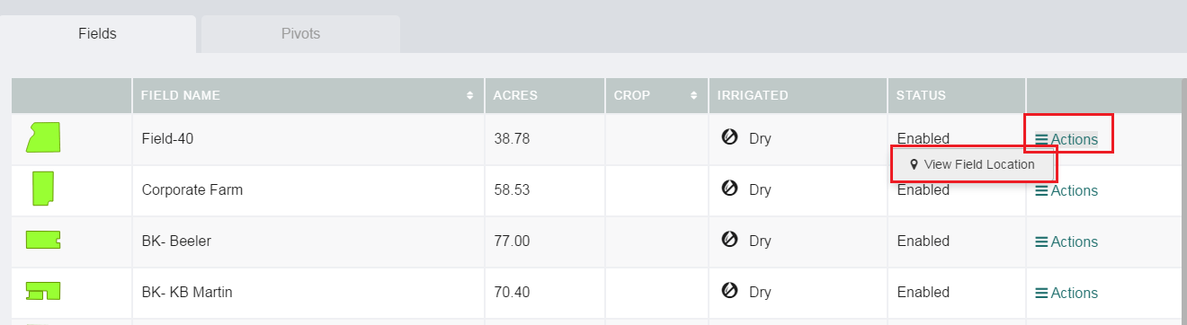

- Add Field – The following changes have been made to the Add Field page.
  - The Grower organization is now displayed.
  - The Farm the field is associated to is displayed above the Field Name entry box.
  - The “Crop Type” field has been relabeled to “Current Year Crop”.
  - The field Latitude and Longitude fields are auto populated when the field boundary is uploaded.

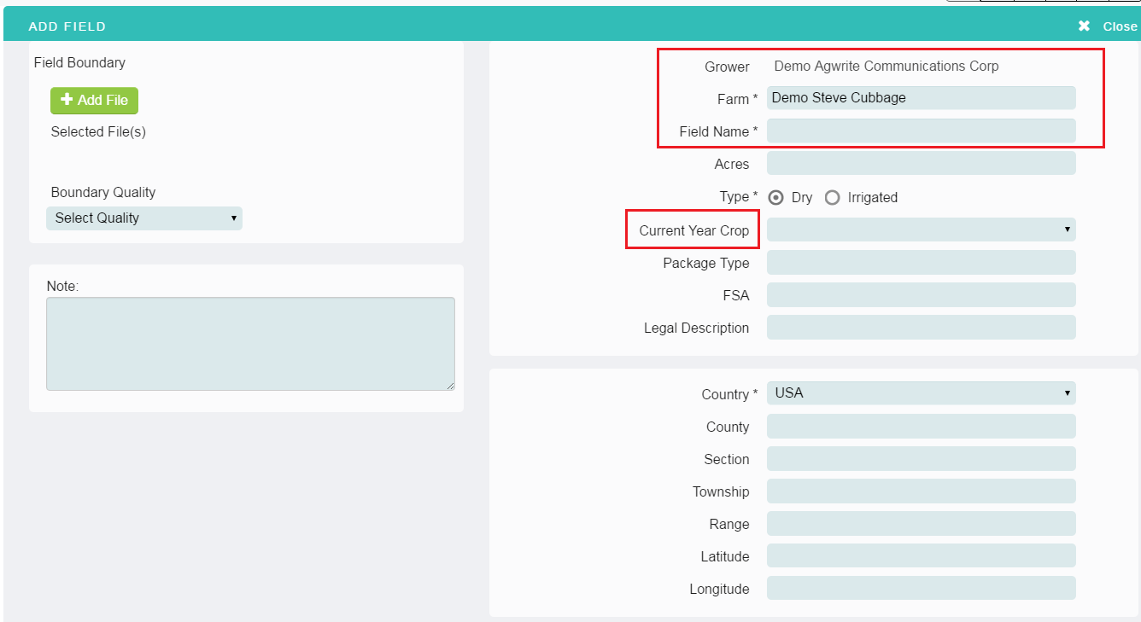

- List Page – Machine Tab – The machine details page can now be printed.

Documents Page:
- Share Documents – A message is now displayed if the size of the files selected to share exceed the email’s maximum size allowed.

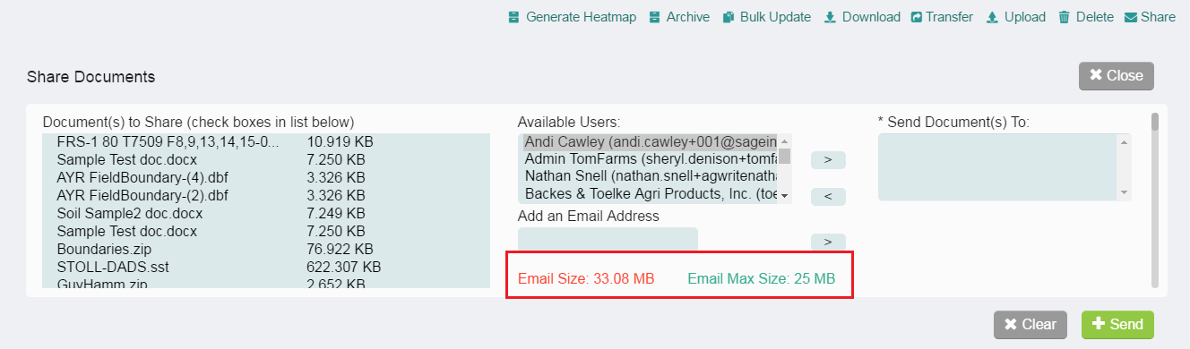

Task Inbox Page:
- Soil Sample work order task – The Farm name is now displayed in the General Information section when the work order form is viewed from the task inbox.

Work Orders Page:
- All Work Orders - The issue with duplicate notes in the work orders has been corrected. The existing work orders will still have duplicate notes. New work orders created going forward will not have the duplicate note issue.

- Crop Scouting Work Order – Crop scouting reports edits can now be done directly to the report displayed within the application versus a separate browser window.

- Soil Sample Work Order – Added the option when “Have Soil Samples” is set to Yes to Upload the Sample Points and Upload the Field Boundary at work order creation. If the Sample Points and Field Boundary are uploaded at work order creation, the Upload Sample Points and Upload Field Boundary steps in the Sample Task are automatically completed.

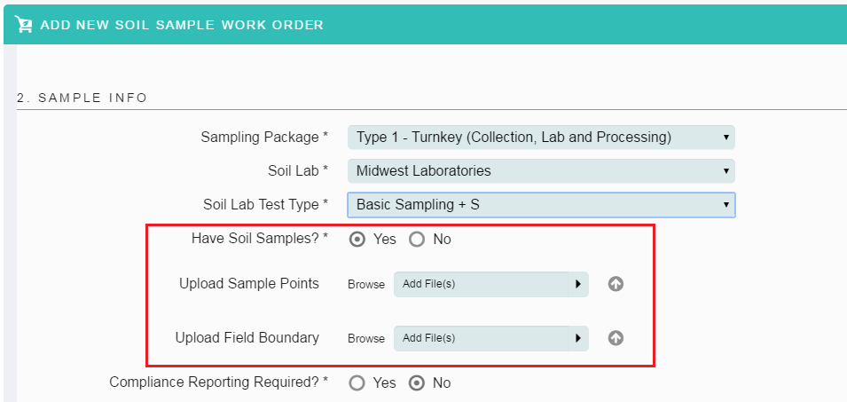

- Soil Sample Work Order – Added a “Skip” option to all steps in all the Tasks in the Soil Sample work order. Provides the user the option to skip steps in the work order if they are not required for the work they are performing for this work order.
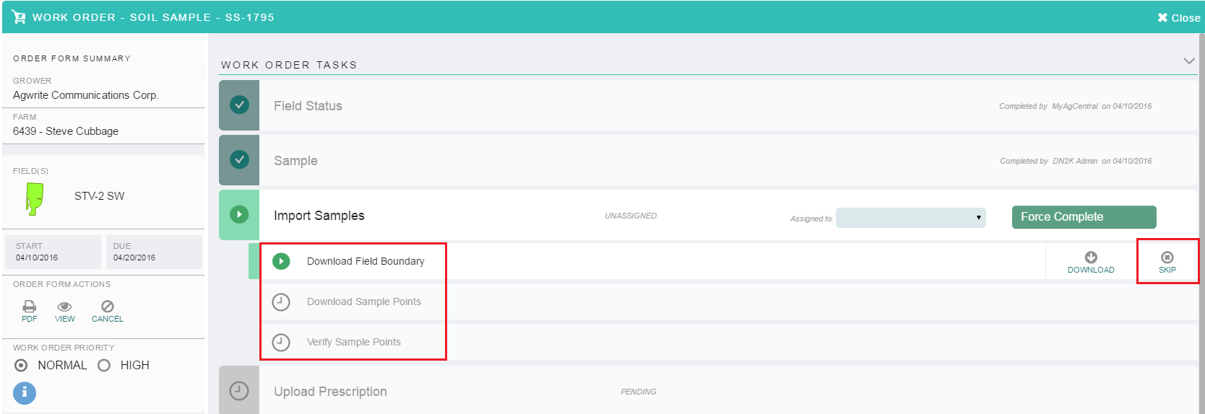

- All Work Orders – The Work order detail now remains open and is not automatically closed when the last task is completed by the user. This provide the user the option to create a PDF of the work order after it is completed without having to reselect and open the work order.

- EC Work Order – The issue with the multiple file upload to the EC work order has been fixed. Multiple files can now be uploaded in the “Upload EC Collection Data” step.

- Tissue Sample Work Order – The last task and step in the Tissue Sample work order has been relabeled “Review Lab Results”.

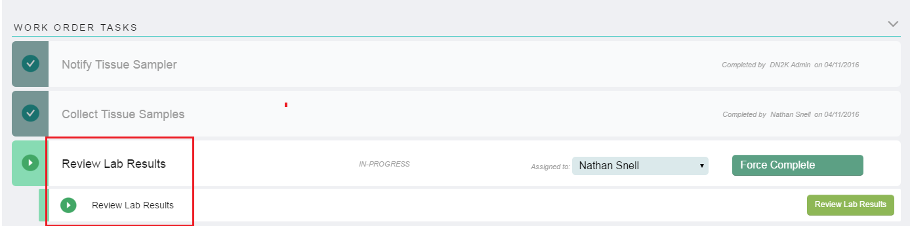

Service/Supplier:
- Supplier list print – The issue with the Supplier print cutting off the far right columns has been fixed. All columns are now displayed when printing the Supplier list.

General:
- Organizations and Assets (Fields, Machines, Pivots, etc.) Detail – Added a free form note box to the organization and asset detail pages to provide the option to add information to assist with the management of the organizations and assets.

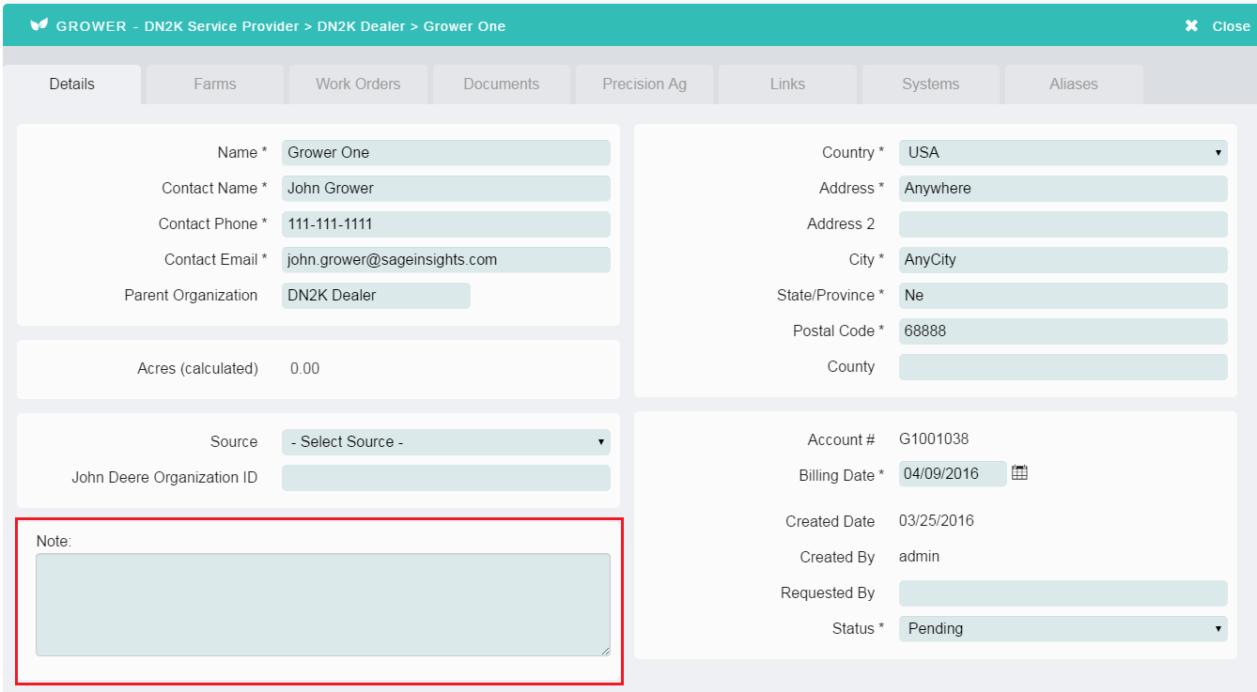

- Multiple organization associated users - The organization navigation panel has been improved to underline and bold the top level organization the user has selected.

- Navigation panel search box – A clear option has been added to the search box in the navigation panel. Click on the “X” in the search box to clear the text entered.

