MyAgCentral 2.6.7 Release Notes
March 14, 2016

The MyAgCentral 2.6.7 release includes the following changes and several miscellaneous bug fixes.

My Organization and Users:

- The Last Date and Time a user has logged in to the application has been added to the User Detail. The Last Login Date and Time is displayed below the user’s Avatar image.

The Last Login Date and Time is obtained from the MyAgCentral audit records. Previously the audit records were retained for 90 days. The retention period has been increased to 180 days. Only users who have logged in during the last 90 days will have a last login date and time. Users who last logged in prior to the last 90 days will show a last login date and time of “Never”.
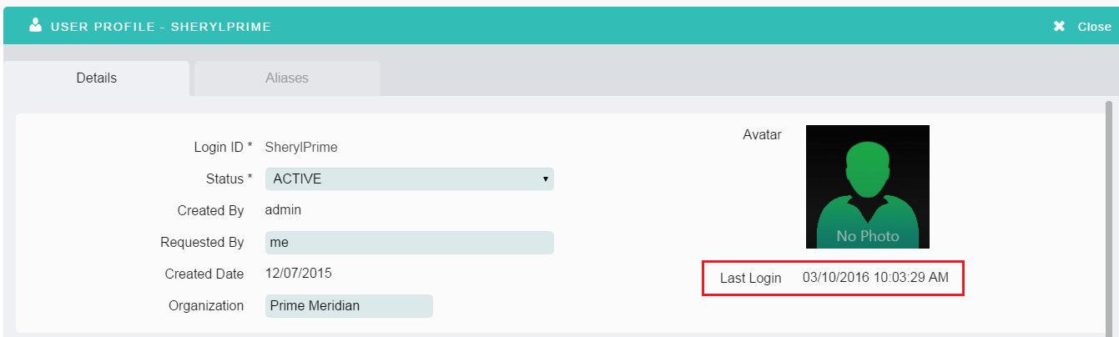

- Add Field Page – The issue with the field boundary files from the previous upload being retained has been fixed. The field boundary files are now cleared out when the field is added.

Fields Page:

- Added Soil Data layers for Dufferin, Grey, Ncypress, Portage, Westborn provinces in Canada to the Field Map page. To view the soil data layers turn the Soils Layer to “On” on the Field Map page.

Documents Page:

- An “Uploaded By” field has been added to the Document Detail page. The field is populated with the User Name that uploaded the document.

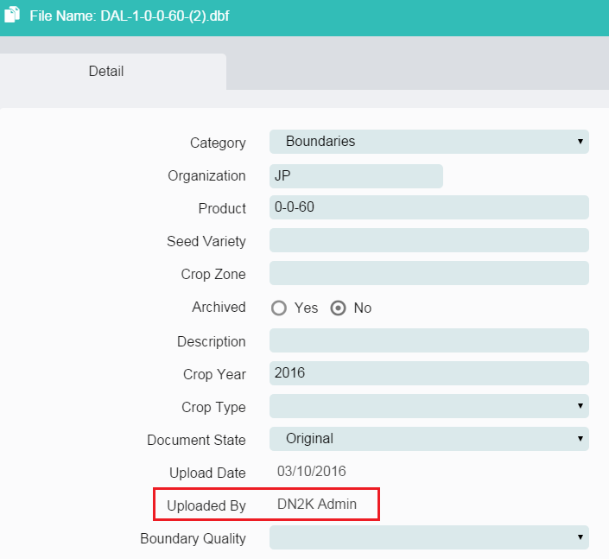

Work Orders Page:

- The Grower, Farm and Field search fields have been added back to the Add Work Order forms.

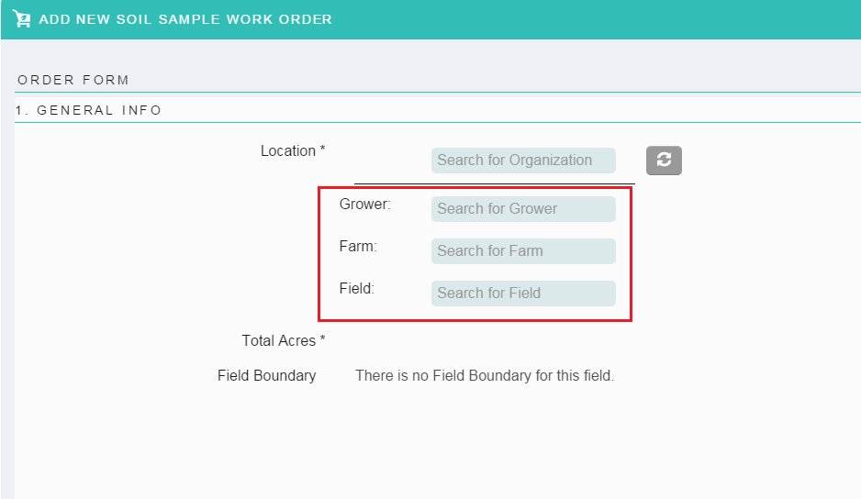

- The ability to assign a Soil Sampler user directly on the Sample Task has been added back to the application. This feature was added to address the issue with existing soil samples work orders not displaying the original assigned Soil Sampler due to the change from using Supplier Organization to Supplier users in the work order drop downs. Can now reassign the existing work orders to a supplier user.

- Work Order drop down – The supplier user drop downs in the work orders now displays the parent organization the users are associated to.

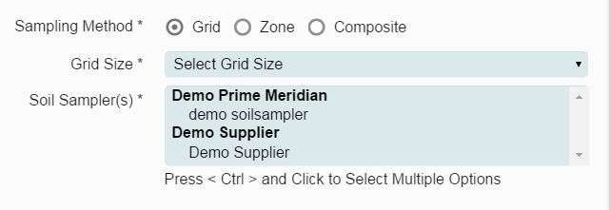

Known Issues:
- Task Inbox – Work Order form - When logged in as a Supplier User the Farm is not populated with the Farm Name in the General Information section of the work order form. The Farm name is visible in the Work Order Summary panel on the left side of the page.

- Imagery Work Order – The Imagery Processor is unable to complete the “Resolve Issue” step.

- Home Page – GFF Widget – Search for and select an Organization in the top Search box. Search for and select a Grower. Change the Organization in the top search box. The Grower organization belonging to the first organization searched and selected is still retained when a new organization is selected.

