**MyAgCentral 2.7.8.1 Release Notes**

**September 28, 2016**

The MyAgCentral 2.7.8.1 release includes the following changes and bug fix.

**Field Activities:**

1. A Field Activities widget and page is now available in MyAgCentral. The data displayed on the Field Activities widget and page are field activity events triggered by the creation of seeding, harvest or application jobs in the John Deere Operations center. Operational data sent from the machine to the John Deere operations center also triggers the entry of a field activity event.

The Field Activities requires an integration to the John Deere Operations center as well as some additional set up. Please contact SageInsights Support to set up the Field Activities integration.

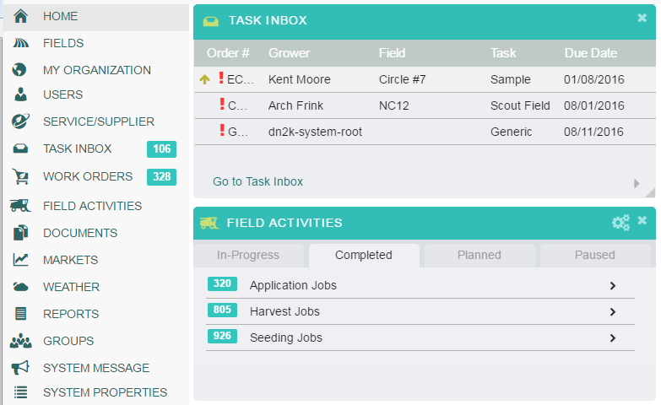

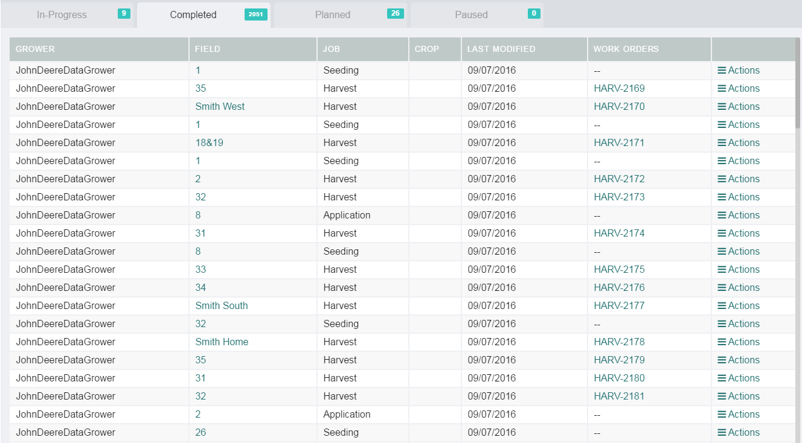

**Work Orders Page:**

1. Soil Sample work order – The following additional Soil Sample work order drop downs are now configurable.

* Recommendations Section - Prescription Formula values
* Product Information Section – Product, Starter, Foliar values
* Product Information Section – Lime Rating values

Please contact SageInsights Support if you wish to customize any of the values for the above drop downs or any of the other drop downs in the Soil Sample work order.

1. Work Order Filters – Users have the option to retain their search selections when moving between pages. When the retain search selection was turned off, the work order filters in the left hand navigation panel were not working. This issue has been resolved and the work order filters are now working correctly.