MyAgCentral 2.6.8 Release Notes
March 28, 2016

The MyAgCentral 2.6.8 release includes the following changes and several miscellaneous bug fixes.

My Organization and Users:

- Add User or User Detail – Multiple Roles – When the Select Roles drop down list is displayed, you can now click outside of the Select Roles dropdown box to collapse the drop down list.
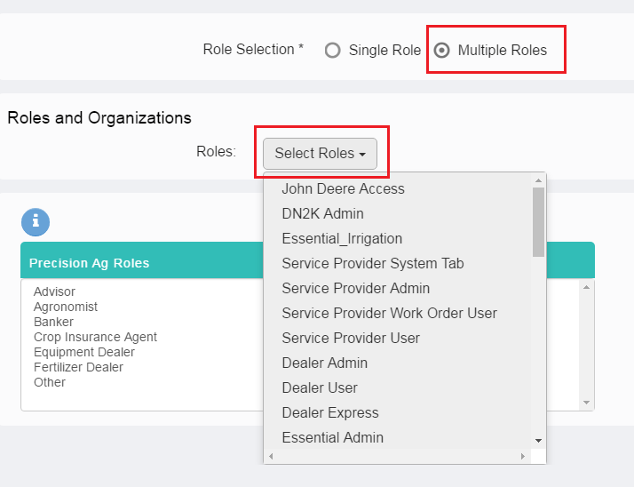

- Add Grower and Add Farm success messages have been changed to indicate the type of organization added.

Add Grower message is now “Grower was successfully created”.

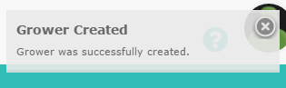

Add Farm message is now “Farm was successfully created”.

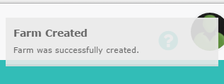

- My Organization – Print View Organization Detail – The License type value is now displayed when printing the Organization detail.
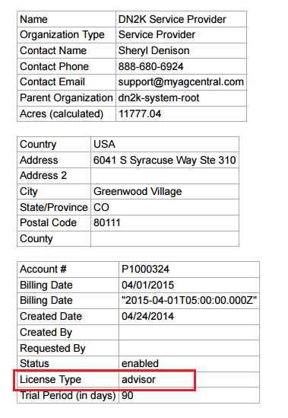

- Field Detail – Select “Irrigated” for the type. The acres input box is now displayed when irrigated type is selected.

- Add Organization – Auto Create user for an organization now returns an error message if the user to be auto created is a duplicate of an existing user.

Fields Page:

- Field Map Page – Add Asset – Add Pivot – Now have the ability to associate a pivot to a field when adding new pivots manually to the application.

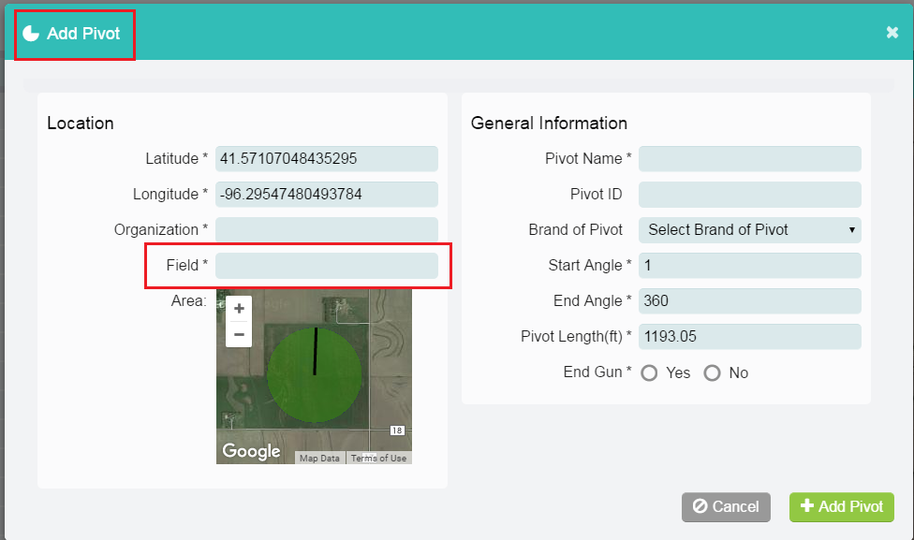

- The ability to access the Remote Display Access (RDA) functionality of MyJohnDeere.com has been added to the application. Machinery with the RDA option is displayed in the left navigation panel with an RDA icon.
  - To view the Remote Display select the Machine.
  - From the Machine Detail panel click on the “Remote Display Access” button.
  - The John Deere login screen is presented.
  - Login to MyJohnDeere to request access to the Remote display.
  - The operator of the machine must accept the RDA request to allow remote viewing.

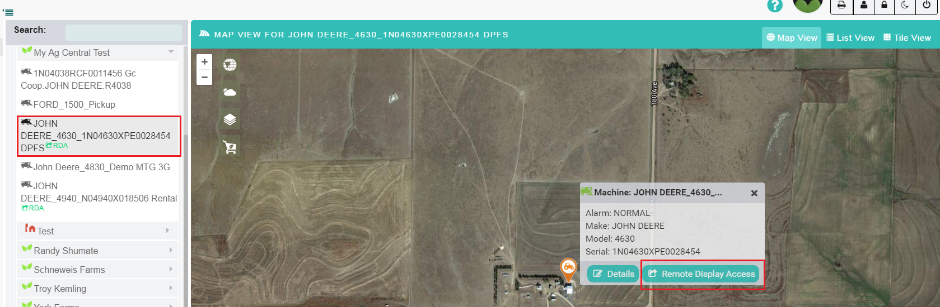

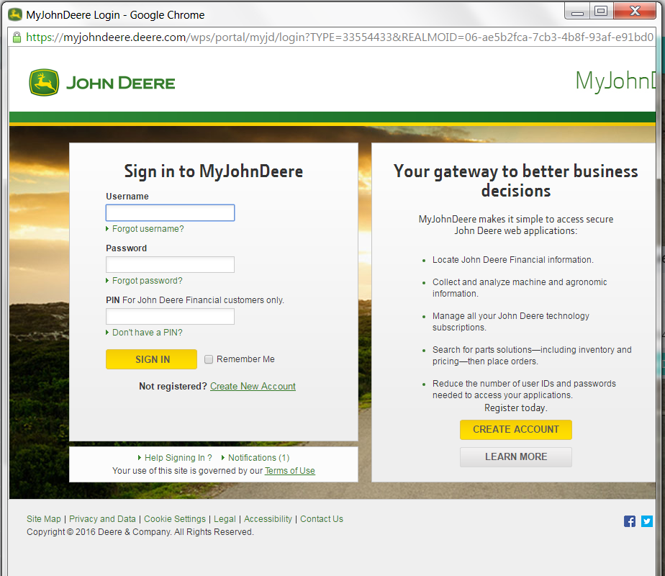

Documents Page:

- Generate Heatmap – A “Reverse Palette” option has been added when generating heat maps with GRID files.

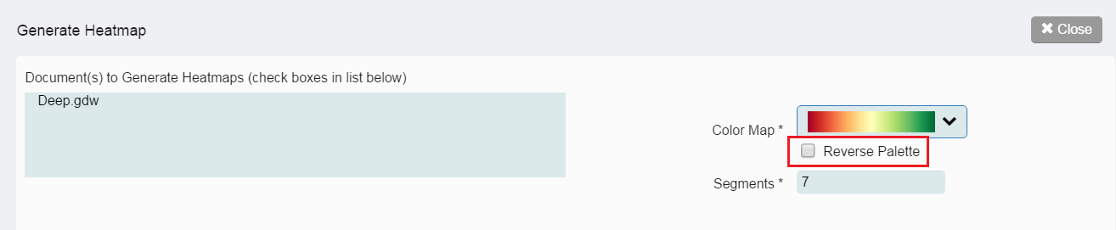

- The breadcrumb displaying the hierarchy structure being viewed has been added back to the document summary list page.

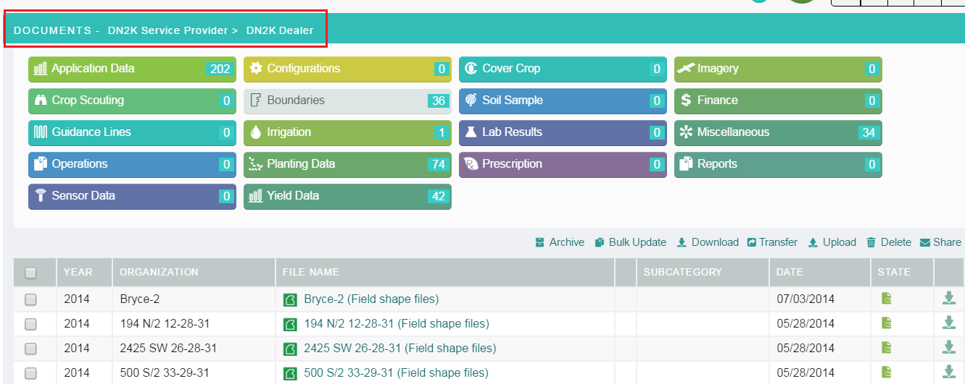

- The Transfer icon has been changed to more clearly indicate the action being performed.

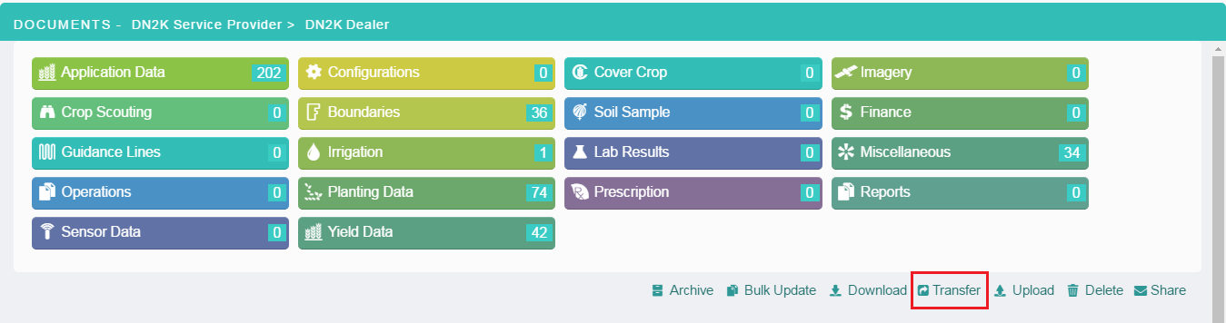

Work Orders Page:

- The breadcrumb displaying the hierarchy structure being viewed has been added back to the work order summary list page.

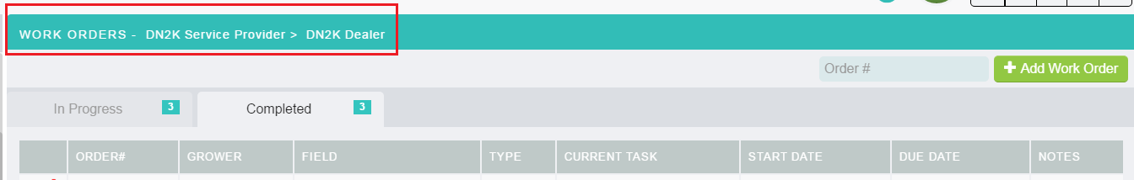

- A new Tissue Sampling work order has been added. The Tissue Sample work order is a task based checklist that includes the following task steps.
  - Notify Tissue Sampler
  - Collect Tissue Samples
  - Send Tissue Samples to the Lab
  - Review Lab Results

Two new user roles have been added.
- Tissue Sampler – Users assigned the Tissue Sampler role will appear in the Tissue Sampler drop down in the Tissue Sample work order form.
- Tissue Reviewer – Users assigned the Tissue Reviewer role will appear in the Agronomist drop down in the Tissue Sample work order form

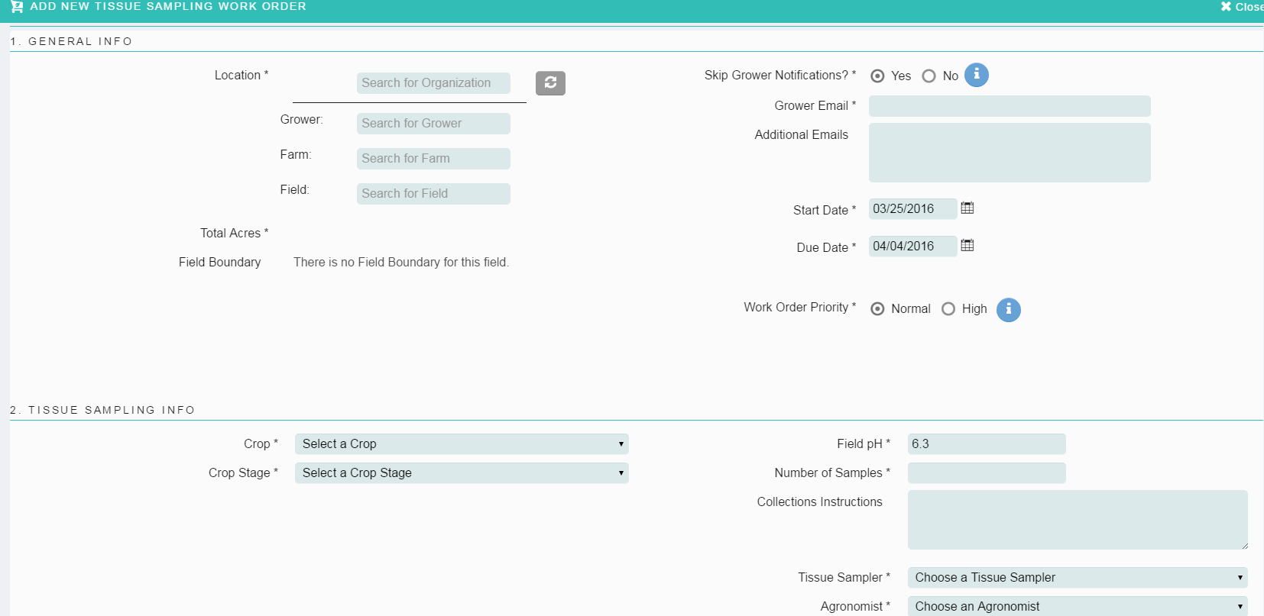

- Soil Sample Work order – Product Information section – An “Applicator Equipment” option has been added. It provides the option to select the type of equipment being used to apply the product.
  - Ag Leader
  - John Deere
  - John Deere WDT
  - Raven
  - Trimble

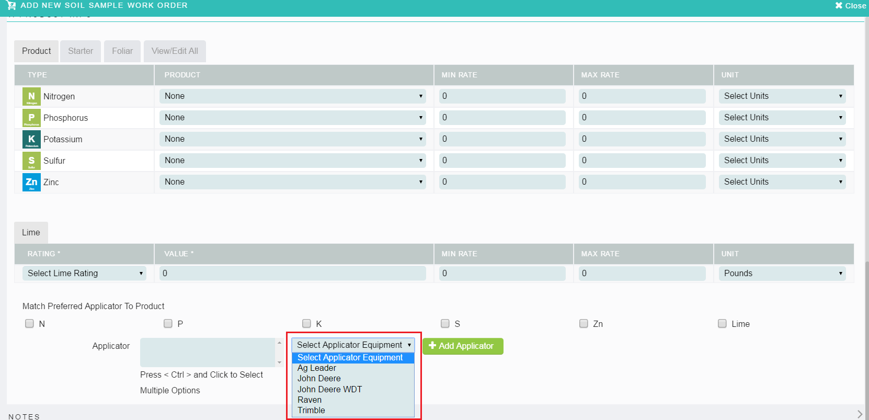

- Crop Scouting work order – The Review Scouting Report task - The Scouting Report is now displayed in a panel in the application versus in a separate browser tab.

- EC Work Orders – Upload EC Collection Data step – The issue with only allowing single file uploads in this step has been fixed. Can now upload multiple files such as shape file bundles and GRID files.

- EC Work order – Sample Task – The Download Field Boundary button is now working in the Sample Task.

- Work orders – Documents section – The issue with the paging indicator not displaying the correct page numbers as been fixed.

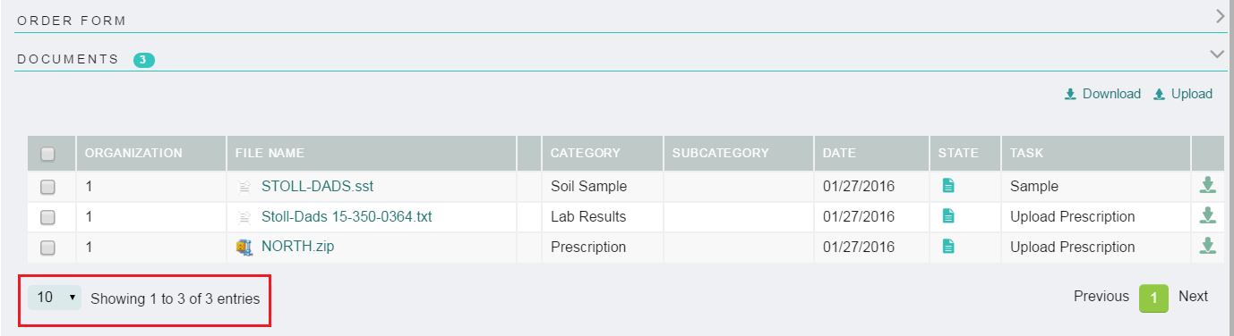

- VRI Work order – The errors that resulted from picking a field without a pivot has been fixed.

- All Work orders – Select a Grower, Farm and Field in the organization navigation panel on the Field page and then click on Add Work order. The Grower, Farm and field selected in the navigation panel are auto-populated in the Add Work order form.

Service/Supplier:

- The organization navigation filter has been removed from the supplier page as the navigation filter does not reflect the supplier organizations. The Supplier list page now displays all Suppliers a user has permission to view.

General:

- Partner Links in the left navigation. If the partner link is opened in the application viewing area versus a new window, the organization navigation panel is no longer displayed allowing for a larger viewing area.

- My Organization and User page – The issue with the organization navigation panel displaying when the User detail is viewed has been fixed. The organization navigation panel is now hidden.

- User Profile – Changes made to the User’s First Name, Last Name and Avatar image via the User Profile Detail are now reflected in the header bar immediately after the update.

Known Issues:

- Mapping Work orders – Multiple file uploads are currently not allowed in the “Upload Processed Files” step.

- VRI Work order – Several errors are displayed when viewing the General information section of VRI work orders.

- Crop Scouting work order – Several errors are displayed when trying to add a crop scouting work order if users with a Crop Scouting role and users with a Crop Specialist role do not exist prior to creating the Crop Scouting work order.

- All Work orders – The Notes section in the work orders have multiple entries for the same note.

- Work order page – Work orders are not displaying when a Farm is selected in the organization navigation panel. Work orders will display when a Grower or Field is selected.

- Fields page – Tile Print View only includes the first 18 fields if more exist.

- Markets page – The Market Print View is cutting off the “Open Interest” column.

- Service Supplier page – The Service Supplier Print View is cutting off the “Owner” column.

- My Organization – When uploading a logo image to an organization, the value in the “Status” field is removed.

- My Organization – When logged in as a multiple role/association user, newly added organizations/growers do not appear in the navigation panel until a refresh of the page occurs.

