MyAgCentral 2.6.6 Release Notes
February 29, 2016

The MyAgCentral 2.6.6 release includes the following changes and several miscellaneous bug fixes.

Home Page:
GFF Express Widget – When the GFF Search option versus the Single Search is used in the GFF widget the Grower and/or Farm search selections are retained after a new Farm or Field is added. This improvement allows adding Farms and Fields to the same Grower or Farm without having to conduct repeated searches to repopulate the Grower and/or Farm fields with the same value.

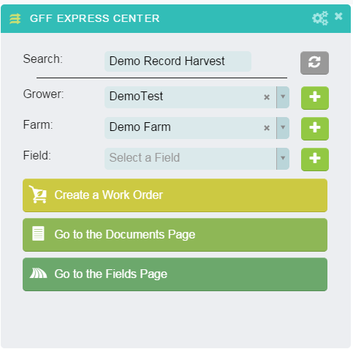

My Organization:
- Users Tab – Add User or Existing User – Multiple Roles – Select any role and click on add organizations (Plus sign). The organization hierarchy selection restrictions by role has been removed. All organization levels for any role can now be selected. For example individual Grower organizations can now be added under the Dealer roles.

- Users Tab – Add User or Existing User – Single Role – All available user roles in the application are now displayed in the Single Role drop down regardless of the User’s parent organization license type.

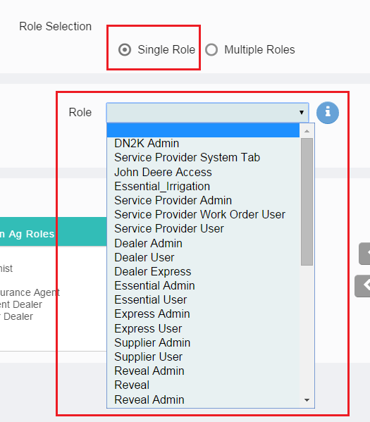

- Links tab – The link URL field is prepopulated with “https://”. Links added to the left hand navigation panel must have be an https:// address. Links added to the Links Widget can be either https:// or http://.

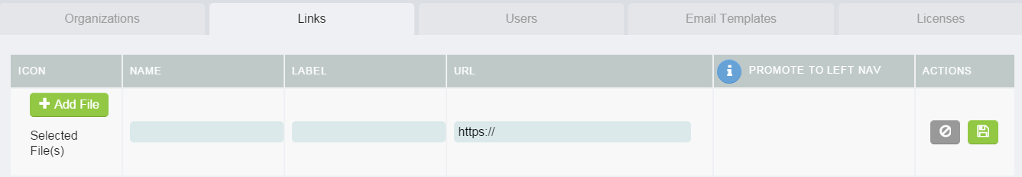

- A Document tab has been added to the Organizations and Field summary list pages. The Document tab displays the document page with all documents associated to the selected organization’s hierarchy.
Known issue the document tab is missing on the Farm list page.

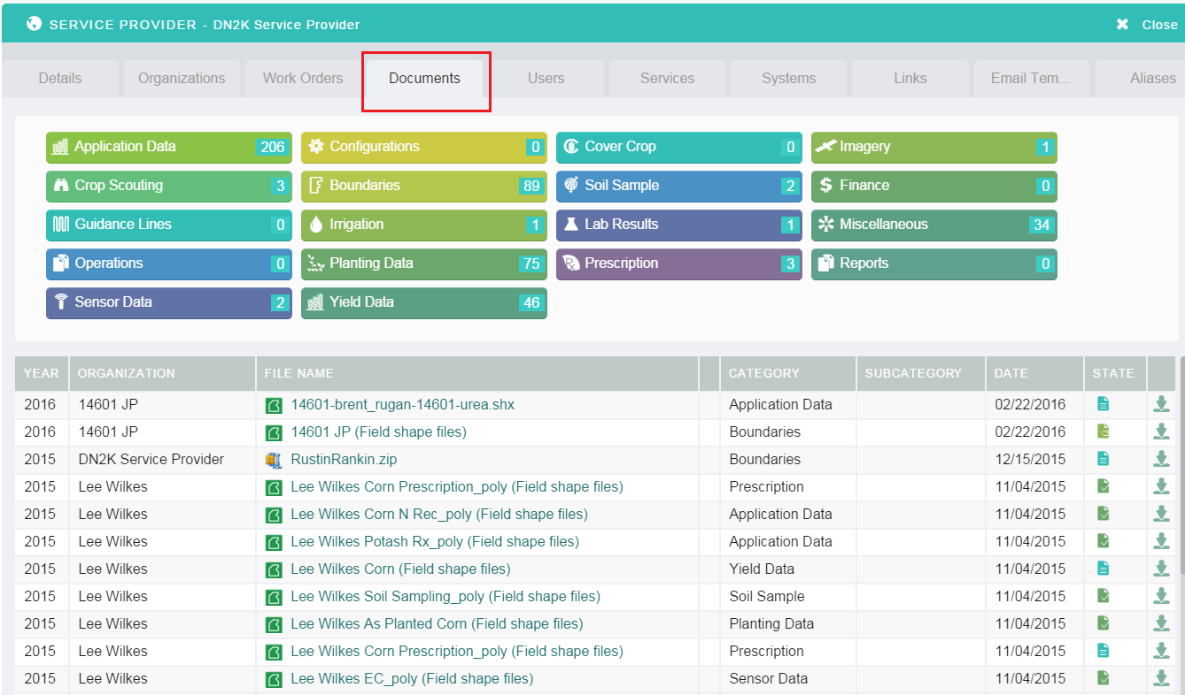

Fields Page:
- The option to upload or draw a field boundary for an existing Field with no boundary has been added. On the Field Map page navigate or search for an existing field with no boundary. Click on “Add Asset” under the Globe icon options. Select the “Add a Field” in the Add Asset options. “Draw New Field Boundary” or “Upload Boundary File” options are displayed.

Selecting the “Upload Boundary File” will present the Add Field panel. Search for the field name in the “Add to Existing Field”. Select the field you wish to upload the boundary to. Upload the boundary files and click the Update button.
Or
Select the “Draw a New Field Boundary” on the map. Select a boundary shape to draw. Draw the field boundary. Click the submit (check mark) button to display the Add Field panel. Search for the field name in the “Add to Existing Field”. Select the field you wish to add the drawn boundary to and click the Update button.

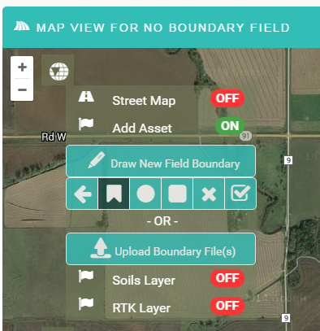

Documents Page:
- Document list – An Organization column has been added to the document summary list that displays the organization or field the document is associated to.

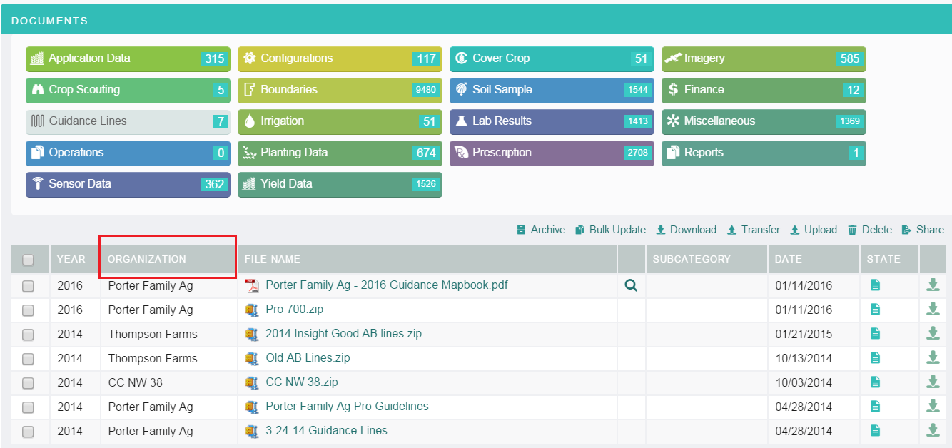

Work Orders Page:
- All Work Orders - A work order priority flag has been added to all work orders. The Work Order summary list now displays the following icons:
  - Overdue work orders are indicated with a red “!”.
  - A work order priority of “Normal” or “High” can now be set at work order creation. The work order priority can be changed on existing work orders by selecting a new priority in the left hand summary panel.

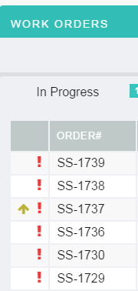

- Yield Map Work order - New options have been added to the “Mapping Info” panel on the Yield Map work order form.
  - Advanced Harvest Map
  - Basic Harvest Map
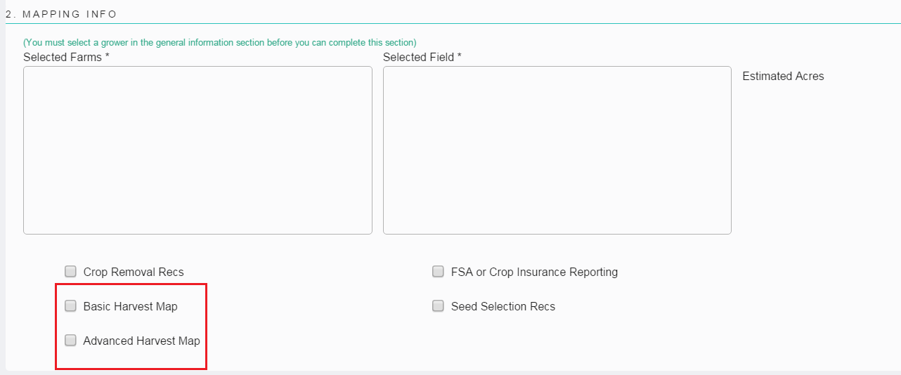

- Soil Sample Work Order:
  - Added an “Info” button to the “Skip Grower Notifications” option on the Soil Sample Work order create form. The info button provides the following description of what the Skip Grower Notifications does.
“When 'Skip Grower Notifications' is set to No, the Grower is sent an email message to approve the sampling of the field. When this option is set to Yes, this email to the Grower is skipped and the Sampling of the field is initiated.”

  - Product Info section - Moved the Lime fields to the product info list.

  - Some of the Soil Sample work order drop down lists can now be customized. Contact SageInsights support to request customization of the following drop downs.

    - Soil Sampling Packages
    - Soil Sample Lab Test Types
    - Soil Sample Laboratories
    - Soil Sample Grid Sizes

- All Work Orders - Previously the Work Order Supplier assignee list was populated with the Services/Supplier organization names. The task the supplier organization was assigned to in the work order was pooled to the task inbox of all the users with the appropriate supplier role associated to the supplier organization.

The Work Order Supplier assignee lists are now populated with any Users that have the appropriate supplier role versus being populated with the Supplier Organizations. Users with a supplier role can be added to organizations via the My Organization page or added to Supplier organizations via the Services/Suppliers page. Supplier only organizations can still be added to the Services/Suppliers page and supplier users added to those organization.

For example the Users with the Supplier Soil Sampler role added either via My Organization or Services/Supplier pages will be displayed in the “Soil Sampler” drop down in the Soil Sample Work Order.

One exception to the above is the Applicator drop down in the Soil Sample work order. The Applicator drop down is still populated with the Supplier organization name versus users with the Applicator role.

Please contact SageInsight support if you need assistance verifying your current supplier users role set up.

General:
- The page navigation panel and organization search/navigation panels can be collapsed to expand the viewing area. A change has been made to retain the collapsed panel state when moving between pages in the application.

- Shape File Upload helper has now been implemented in all areas of the application where shape file bundles are uploaded. The Shape File Upload helper notifies the user if required files in the Shape file bundle are missing and indicates which files are missing. The user can then upload the missing shape files via the Shape File Upload helper panel until all required files have been uploaded.

- A Print option has been added to the primary pages in the application as well as some of the detail page views. Click on the “Print” icon in the header bar to present the Print panel. Pages not available for printing will display a message “No printable content is available for this page” when hovering over the print icon.

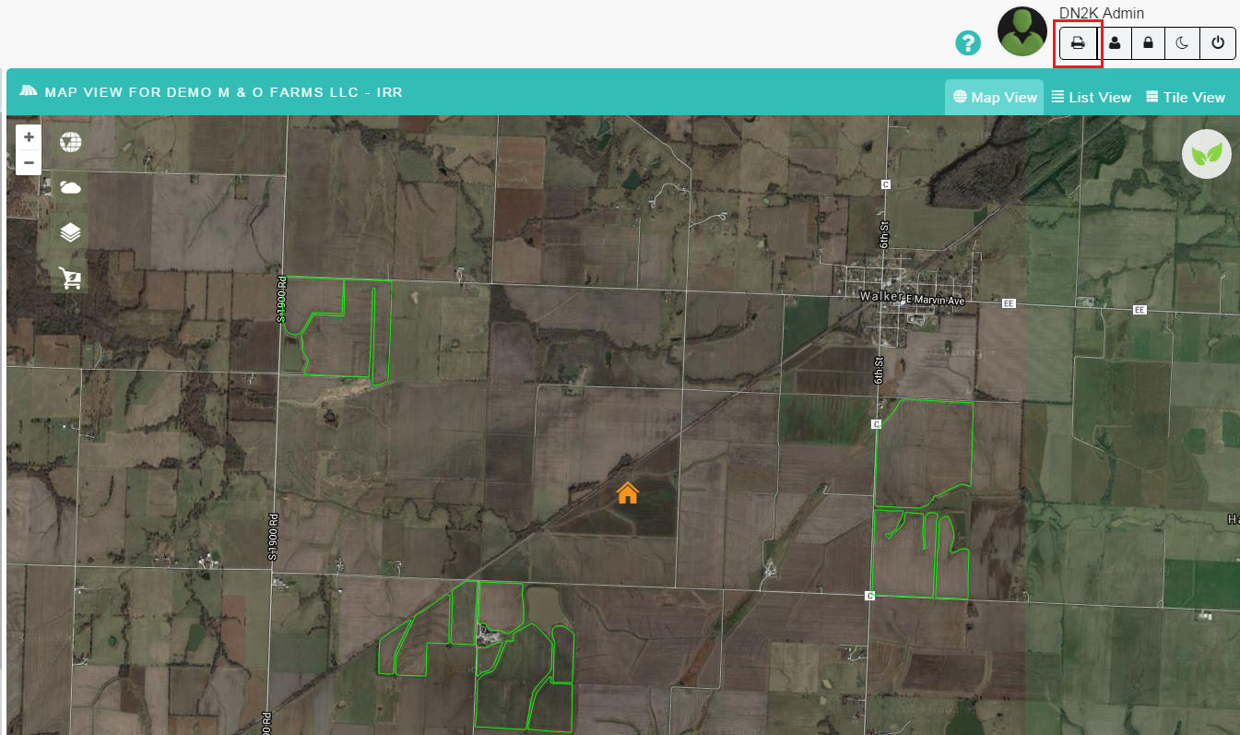

- All pages except the Services/Supplier page – Table lists display option – The table list display default is set to 20 entries in the table. The user can select to display 10, 20, 50, or 100 entries. The selected display option is now retained when a user views the detail for an entry in the list and then closes the detail to return to the list.
Known issue that the list does not remain positioned on the entry just viewed when closing out of the detail page.

- The known issue with the navigation tree position not reflecting the selected search results has been corrected. The organization navigation tree now positions on the organization selected in the search versus being positioned at the top of the organization tree.

